PRE AND POSTNATAL DEVELOPMENT OF ALBINO RAT OVARY UNDER THE EFFECT OF HYPOTHYROIDISM AND ROLE OF THYROID REPLACEMENT THERAPY
"A Light And Electron Microscopic Study"
Thesis
Submitted For Fulfillment Of M.D. Degree
In Anatomy And Embryology
By
Bodour Qassim Badr Eldeen
M.B.B ch., M.Sc. Degree In Anatomy & Embryology
Benha Faculty Of Medicine
Under Supervision Of
Prof. Dr. ABD ELWANEES AMIN AL.AWDAN
Professor Of Anatomy& Embryology, Benha Faculty Of Medicine

Prof. Dr. SAADIA AHMED SHALABY
Professor Of Anatomy & Embryology, Benha Faculty Of Medicine

Prof. Dr. ESSAM MOHAMED EID
Professor And Head Of Anatomy & Embryology Department.
Benha Faculty Of Medicine

Prof. Dr. Omar Abdelaziz Allam
Assistant Professor Of Anatomy & Embryology, Benha Faculty Of Medicine

Anatomy Department
Benha Faculty Of Medicine - Benha University
2013

ACKNOWLEDGMENT

First and Foremost thanks to GOD.
I would like to express my deepest gratitude and sincere thanks to Prof. Dr. Abd-El-Wanees Amin AL-Awdan for his great help and encouragement in initiating and completing this work. He truly is a rare example of excellence, success and wisdom.
I am also greatly indebted to Prof. Dr. Saadia Ahmed Shalaby, Professor of Anatomy, for her wise guidance, judgments, patience, motivation and supervision. She provided me with endless help and support and her effort never been forgotten.
I would like to sincerely thank Prof. Dr. Essam Mohammed Eid, Professor and Head of Anatomy, for his meticulous supervision, continuous encouragement, immense knowledge and great effort he expended with me throughout this study.
Last but not least, I would like sincerely to thank Assis. Prof. Dr. Omar Abdelaziz Allam, Assistant Professor of Anatomy, for his wise guidance, expertise and supervision. His judgments were great, helping me to conduct this work..

CONTENTS

INTRODUCTION | 1
AIM OF THE WORK | 2
REVIEW OF THE LITERATURE | 3
- Anatomy of the ovary | 3
- Histology of the ovary | 5
- Development of the ovary | 10
- Ovulation | 27
- Estrous cycle in rats | 29
- Ovarian hormones | 32
- Thyroid gland and thyroid hormones | 37
- Hypothyroidism | 40
- Antithyroid drugs | 45
- Thyroid hormone replacement | 50
MATERIALS AND METHODS | 51
RESULTS | 55
DISCUSSION | 144
SUMMARY AND CONCLUSIONS | 155
REFERENCES | 158
ARABIC SUMMARY

LIST OF ABBREVIATION

PTU | Propylthiouracil
RBCs | Red Blood Corpuscles
RER | Rough Endoplasmic Reticulum
T₃ | Tri-iodo-thyronine
T₄ | Thyroxine
TRH | Thyrotropine Releasing Hormone
TSH | Thyroid Stimulating Hormone

INTRODUCTION
I
n mammals, the ability of reproduction is limited due to limited numbers of oocytes which were produced from the primordial germ cells that came to the ovaries (Nicholas, et al., 2010).
The development of mature ovary is greatly dependant on thyroid function, as thyroid hormones play a role in regulation of reproductive hormone secretion in cyclic rat ovary (Domnguez, et al., 1985; Cecconi, et al., 1999; Cecconi, et al., 2004; Hatsuta, et al., 2004a and Jiang, et al., 2008). Slebodzinski (2005) reported that the Iodine concentration in the ovary is higher than in other organs except thyroid.
Disorders of thyroid in women are common during reproductive years. Incorrect or delayed treatment during pregnancy can adversely affect the health of mother and fetus (Möing et al., 2010). Such in case of inadequate thyroid hormone supply (Hypothyroidism), there is disturbance of folliculogenesis and mal-development of ovary (Dijkstra et al.; 1996).
Recent experimental evidence showed that the changes in female sex hormones level were recovered by administration of thyroid replacement therapy in hypothyroid female rat (Hatsuta et al., 2004b).
However, the studies on the involvement of thyroid hormone in repairing ovarian follicle mal-development in immature hypothyroid rat are rarely demonstrated. So further studies in the pre and postnatal developing ovaries are important for understanding the female infertility that is associated with hypothyroidism.

AIM OF THE WORK

This work aimed to:
- Study the effect of hypothyroidism on the pre and postnatal development of albino rat ovary.
- Evaluate the role of thyroid replacement therapy on the development of hypothyroid rat ovary.

ANATOMY OF THE OVARY
In the rat:
P
aired ovaries are grape like structures that vary in gross appearance and size. Each ovary is global in shape and suspended from the dorsal abdominal wall by the mesovarium. In rodents, which have long and straight uterine horns, the ovaries are located in the caudal portion of the lumbar region posterior to the kidneys (Fig. 1). In primates, the body of the uterus is short and the ovaries are almond (amygdaloidal) in shape and located in the pelvic region (Qing et al., 2008 ).
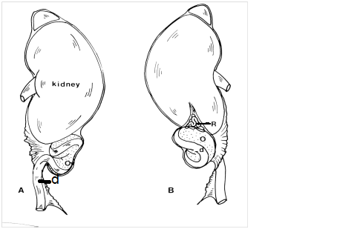

Fig. (1): Left rat kidney. (A) Ventral view, (B) Dorsal view showing: ovary (O), oviduct (d) and rete ovarii (R) (Rajah, et al., 1992).
In the human:
The human mature ovaries are paired nodular structures 1 x 2 x 2.5 cm and 4 to 8gm, in weight which is varying during the menstrual cycle. Ovaries are situated close to the lateral pelvic wall (in the ovarian fossa) and attached to the posterior surface of the broad ligament by a fold of the peritoneum, the mesovarium, which transmits vessels and nerves to the hilum. The ovaries are attached to the uterus by the ovarian ligament and lie in close association with the uterine tubes (Fallopian tubes) (Goldfien and Monroe, 1997).
Blood supply of the ovary:
The central zone of the ovarian stroma, the medulla, is highly vascular being supplied mainly by the ovarian artery, a branch of the aorta, and also receives blood from the uterine artery, through their anastomotic connections. They enter the hilum of the ovary from the broad ligament, then branch and coil to become known as helicine arteries. Smaller branches from a plexus at the cortico- medullary junction giving rise to straight cortical arterioles which radiate into the cortex. They branch and anastomose to form vascular arcades which give rise to a rich network of capillaries around the follicles. Venous drainage follows the course of the arterial system, the medullary veins being particularly large and tortuous, leaving the ovary at the hilum. Lymphatics arise in the perifollicular stroma draining to larger vessels which coil around the medullary veins. Although the lymphatic channels are numerous in the theca externa, corpora lutea, and corpora albicantia, they are not seen in the theca interna, granulosa or tunica albuginea (Goldfien and Monroe, 1997).
Nerve supply:
The ovary has a rich autonomic innervation arising from the intermesenteric nerves and renal plexus, superior hypogastric plexus; and the inferior hypogastric plexus. The nerves appear to be sympathetic in origin, which do not only supply blood vessels but also terminate on smooth muscle cells in the stroma around the follicles possibly playing some part in follicular maturation and ovulation (Greenspan and Strewler, 1997).

HISTOLOGY OF THE RAT OVARY

Very little is known about the histogenesis of the rat ovary (Rajah et al., 1992). It was known that the mammalian ovary shows extensive variations mainly in relation to interstitial tissue of the ovary and the degree of gonadal regionalization. In the rat, ovarian regionalization is much less relevant than other species and ovarian organogenesis is, exceptionally, simple (Jimenez, 2010).
The gross and microscopic appearance of the ovary varies with the stage of the reproductive cycle (Korach and Quniby, 1985).
The ovarian surface reflects the stage of the reproductive cycle and may have grossly visible follicles and corpora lutea. These structures often protrude from the ovarian surface, thus giving rise to (grape - like appearance) of the ovary (Fig. 2). The surface of the ovary is covered by a single layer of mesothelium (germinal epithelium) and not covered by peritoneum. This specialized (modified) peritoneal mesothelium may be squamous, cuboidal or columnar (Harrison & Weir, 1977).
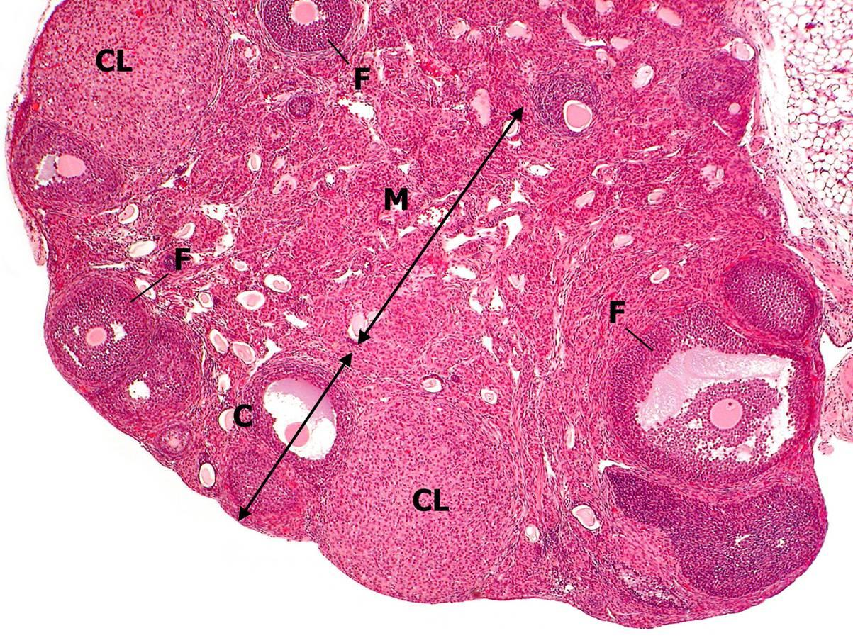
Fig.(2): Subgross anatomy of the normal rat ovary, H&E x40). The cortex (C) contains numerous follicles at various stages of maturation. The medulla (M), which is not always present in histological sections, contains lymphatics, nerves and numerous blood vessels. It also shows corpus luteum (CL) and developing follicles (F). (Creasy, et al.,2008)
The epithelial covering of the ovary, gives it, a dull grey surface. However the smooth peritoneum of the mesovarium has a shining appearance. The transition between peritoneum and ovarian epithelium is usually marked by a white line around the mesovarian border of the ovary (Standring et al., 2008).
Beneath the mesothelium is a thin pale staining avascular layer of connective tissue called the tunica albuginea or lamina propria, which consists of collagen fibers arranged parallel to the surface of ovary. The parenchyma below the tunica albuginea can be divided into two poorly demarcated zones (Fig. 2). The outer zone, or cortex, contains the ovarian follicles, corpora lutea, interstitial glands and other glandular structures embedded in a highly cellular compact stroma. Nerves and blood vessels

